Staff | Employee Leave Management System
User Manual
Staff | Employee Leave Management System is a complete web application and collection of programs designed to assist an organization in administering its executive responsibilities on a day-to-day basis.
All Hours is a cloud-based leave management system that enables you to efficiently manage, approve, and track leave requests and absences from any device. This app, Stop losing paper forms, Reduces administration, Time-off accruals, and much more.
With All Hours you can easily track all types of leave, including annual leave, sick leave, public holidays, private or unpaid leave, or the usage of surplus hours.
Absence types can be completely customized and counted in days or hours as paid or unpaid time, that way it’s easy to track work done from home and other types of remote work.

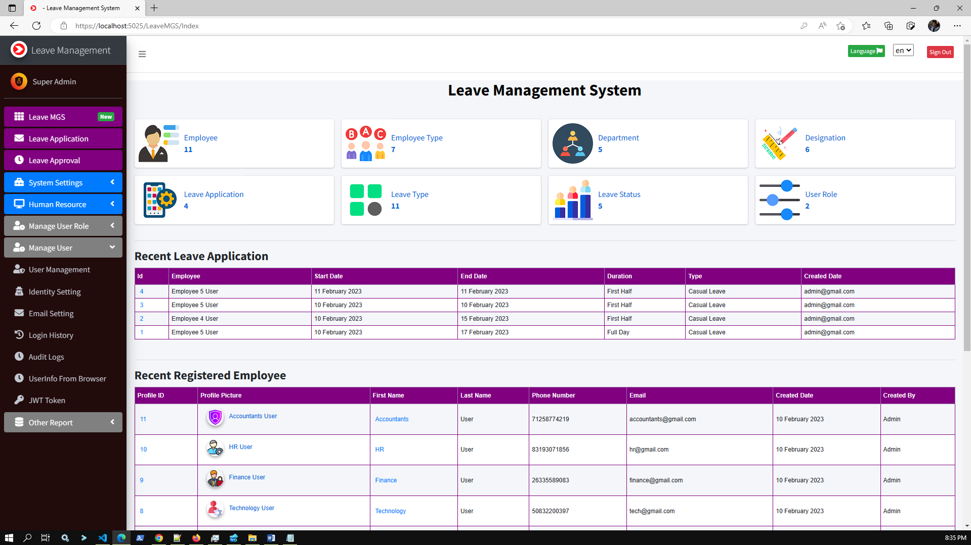

Core Feature
Leave Application
As an employee user I can raise leave application by selecting leave type using this system. And approver user can approved or reject it after reviewing the leave application.

Dashboard
Dynamic dashboard with recent leave application and recent registered employee.

Reports
Get comprehensive insights into your organization with detailed reports designed for you.

Admin LTE Theme
Use the excellent and responsive theme in a low ambient light environment to reduce eyestrain. It provides a range of responsive, reusable, and commonly used components.

Settings
Easily manage the app with settings for logo, system default data, variants, custom page access, and identity option.

Much more
User login history, user management, email configuration, nice UI.

Core Business Feature
- Employee management
- Leave application management
- Leave approval management
- Employee attendance management
- Attendance report
- Leave Summary report

Technical Features
- ASP.NET Core 6.0
- Multi-Language supported
- Dynamic User Role Management
- Audit Logs supported
- EF Core code first
- Identity Core
- MSSQL/MySQL
- Partial page update CRUD operation
- Razor and jQuery for FE
- jQuery DataTable for faster data load
- Sweet Alert2 and Toaster notification
- select2 dropdown
- ASP.NET Core MVC Architecture
- Swagger for API documentation
- Dependency Injection
- Standard Naming conventions
- JWT Token Based Authentication and Claim Based Authorization
- All Methods are Async/Await
- CORS Settings
- Docker Support

Technologies:
Microsoft Visual Studio Community 2022 or later, ASP.NET Core 6.0, Identity Core, Entity Framework Code First, MSSQL SERVER 2017/MySQL, AdminLTE 3.0.5, JavaScript, jQuery data table, bootstrap 4, sweetalert, toastr, Fontawesome etc.

Prerequisite Application:
Microsoft Visual Studio Community 2022 or later, .Net Core 6.0, MS SQL SERVER 2017/or later/MySQL, IIS, Chrome/Edge Browser.

How to run this Project:
Step 1:
Unzip the downloaded zip folder (LeaveMGS.zip)
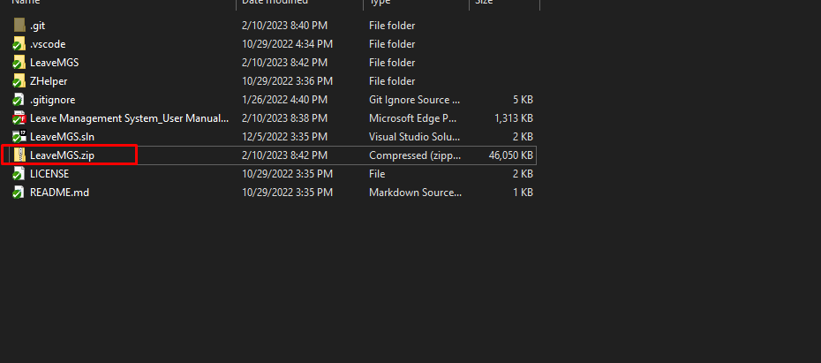

Step 2:
Open LeaveMGS.sln file with Visual Studio 2022 Or Later Version/VS Code
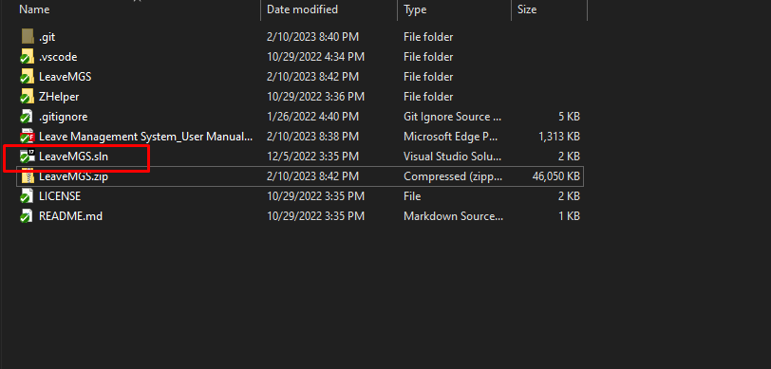
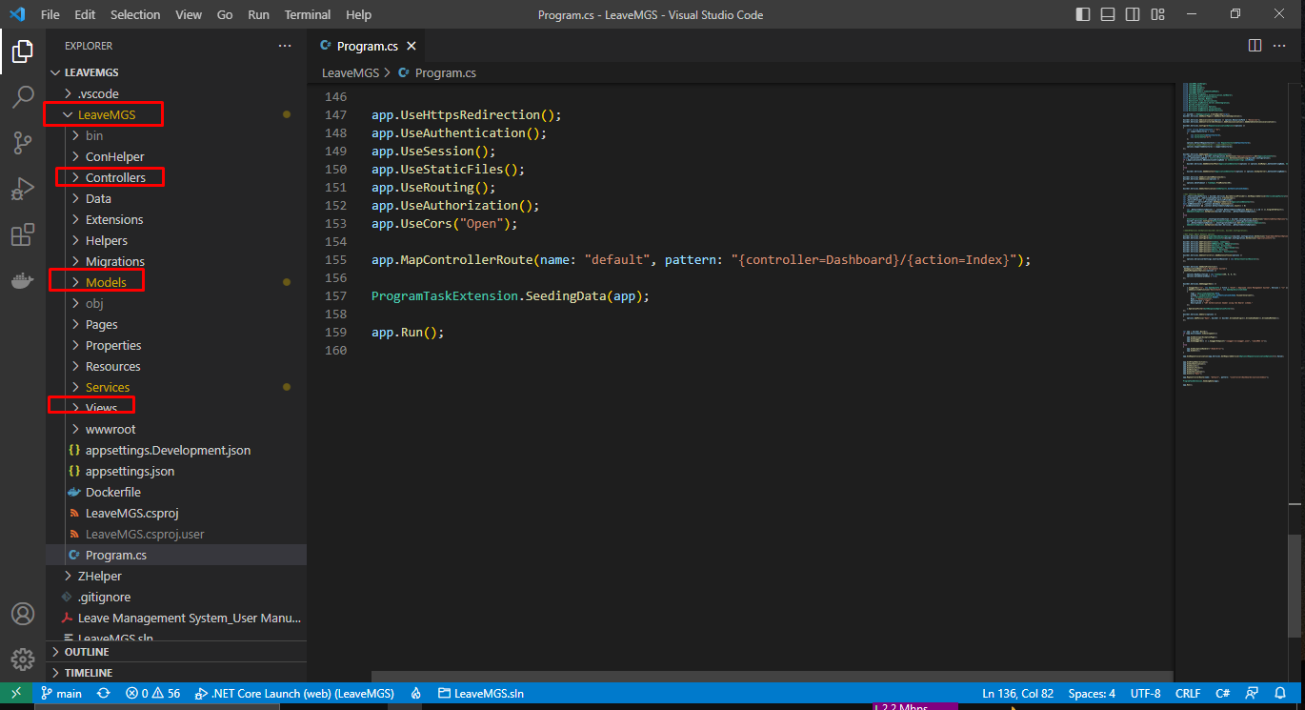

Step 3:
Update database connection: appsettings.json
“DefaultConnection”: “Server=DEVSTATION\\MSSQLSERVER2017; Database= LeaveMGS;User ID=sa;Password=dev123456”
Server=Your MSSQL Server Name
User ID= Your MSSQL Server User Name
Password= Your MSSQL Server User Password
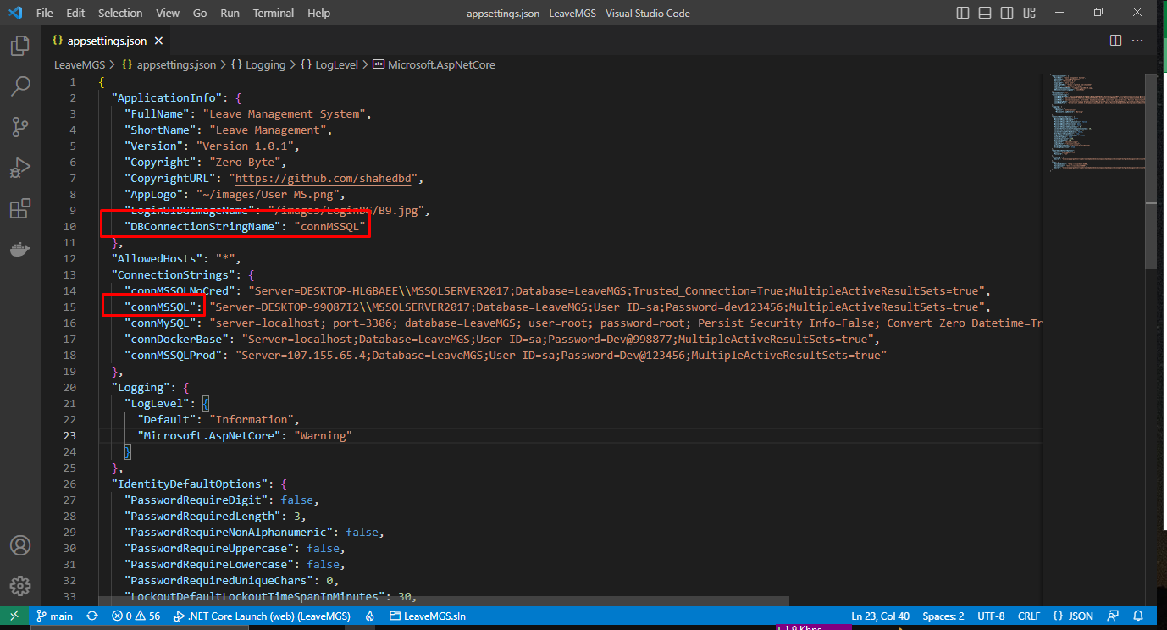

DB Notes:
public const string connMSSQLNoCred = "connMSSQLNoCred";
public const string connMSSQL = "connMSSQL";
public const string connMySQL = "connMySQL";
public const string connDockerBase = "connDockerBase";
public const string connMSSQLProd = "connMSSQLProd";
public const string connOthers = "connOthers";
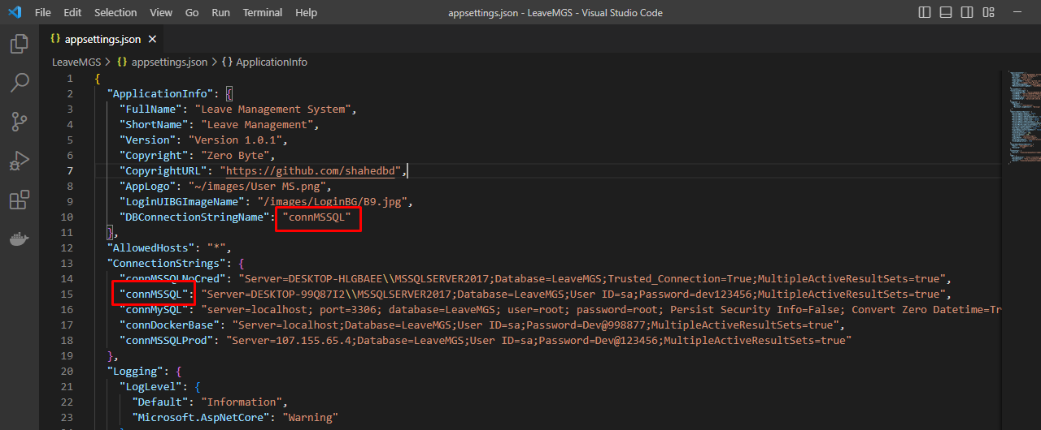

Step 4:
No need to create new migration rule and update database. You just need to build and run the application. Already initial migration rule included with project. Please make sure MS SQL server running properly.
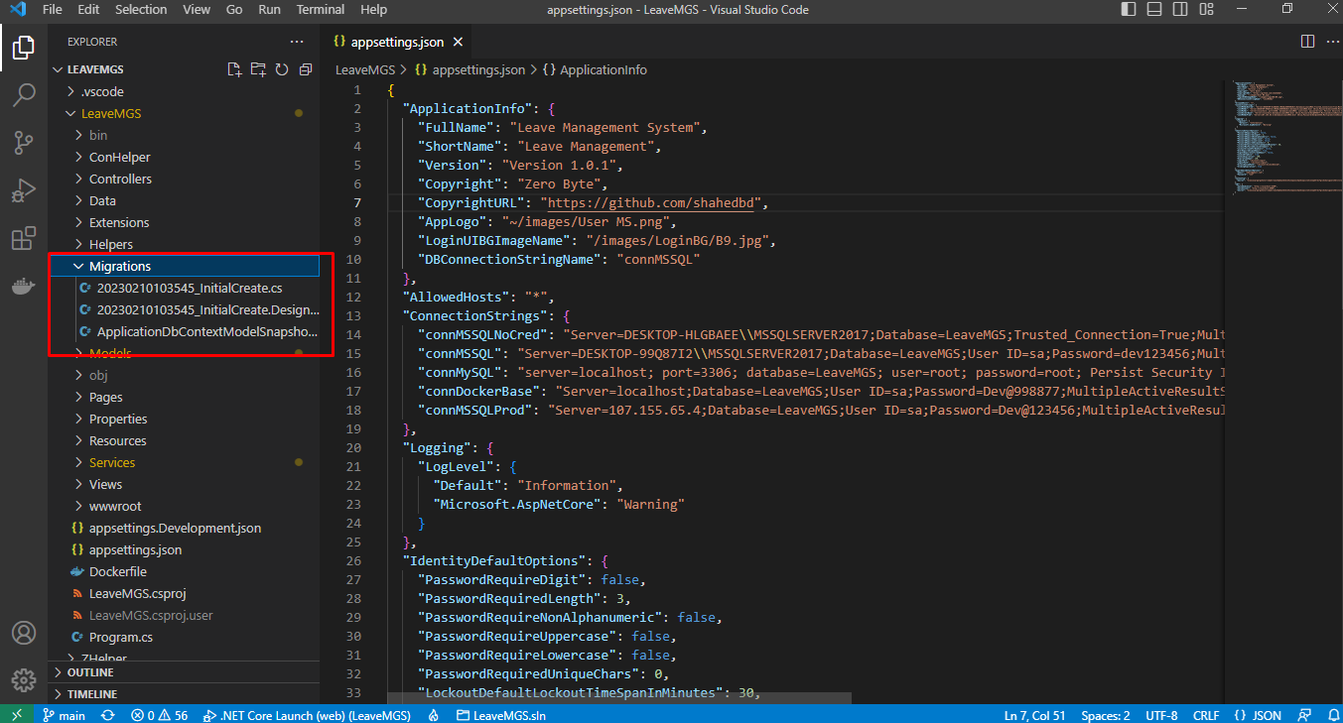

Step 5:
5.1: Build application by pressing f6
5.2: Run application by pressing f5
https://localhost:5025/Account/Login
User Name: admin@gmail.com
Password: 123

Swagger:
http://localhost:5025/swagger/index.html

Initially in the SQL server, relevant tables and data will be created in the database dynamically as code first approach.

Step 6:
Browse full application.
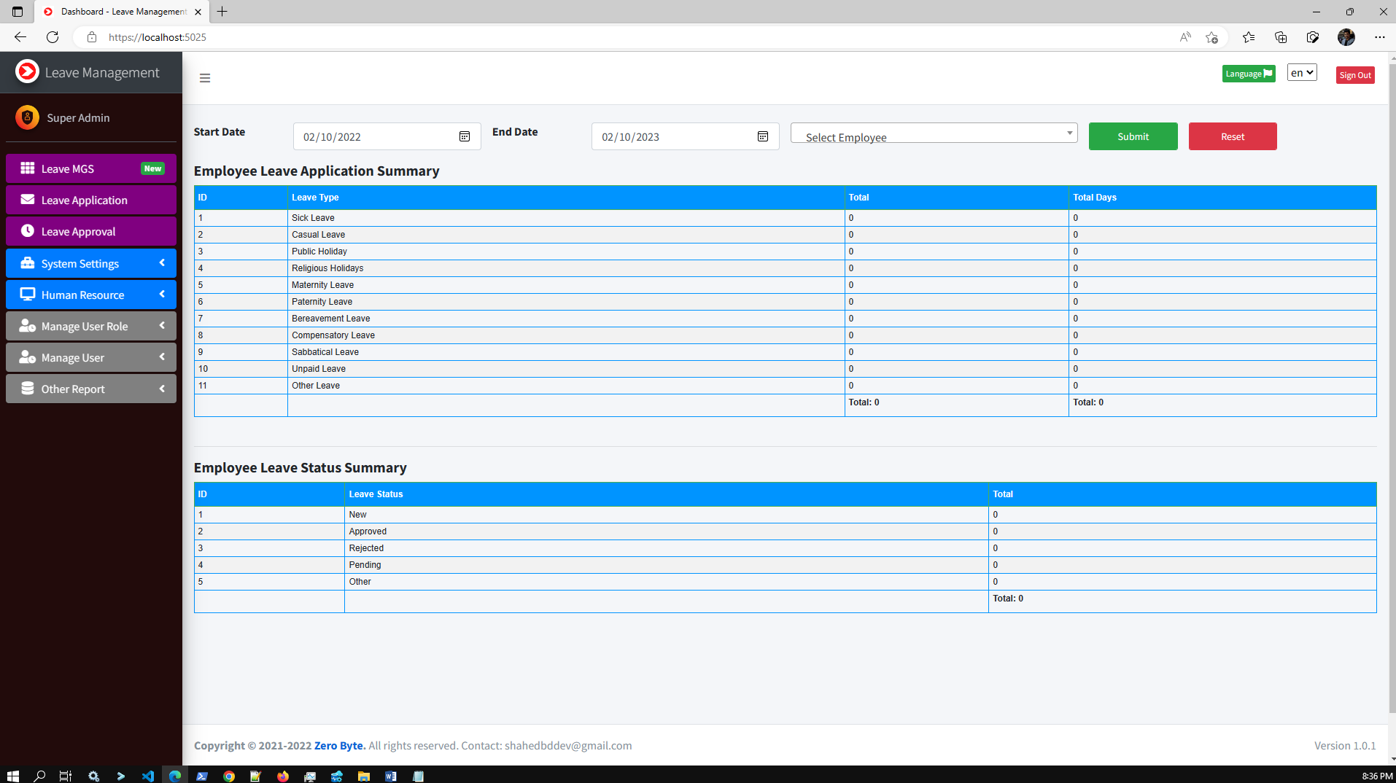
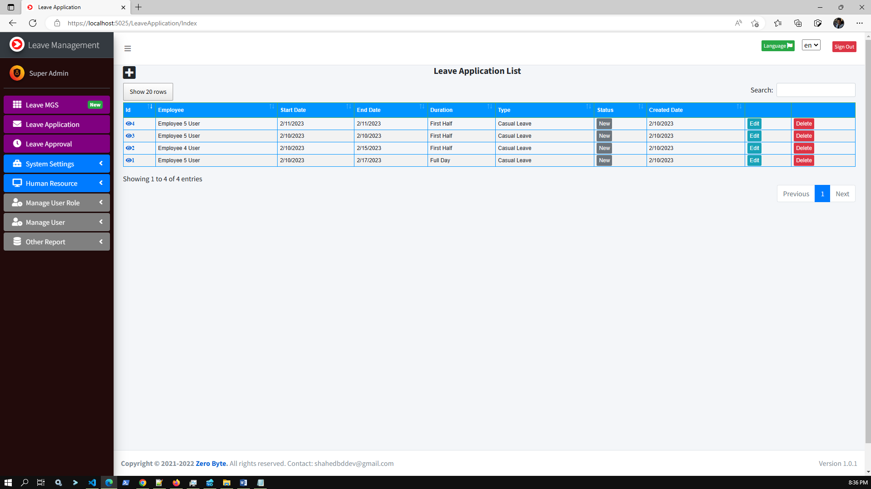
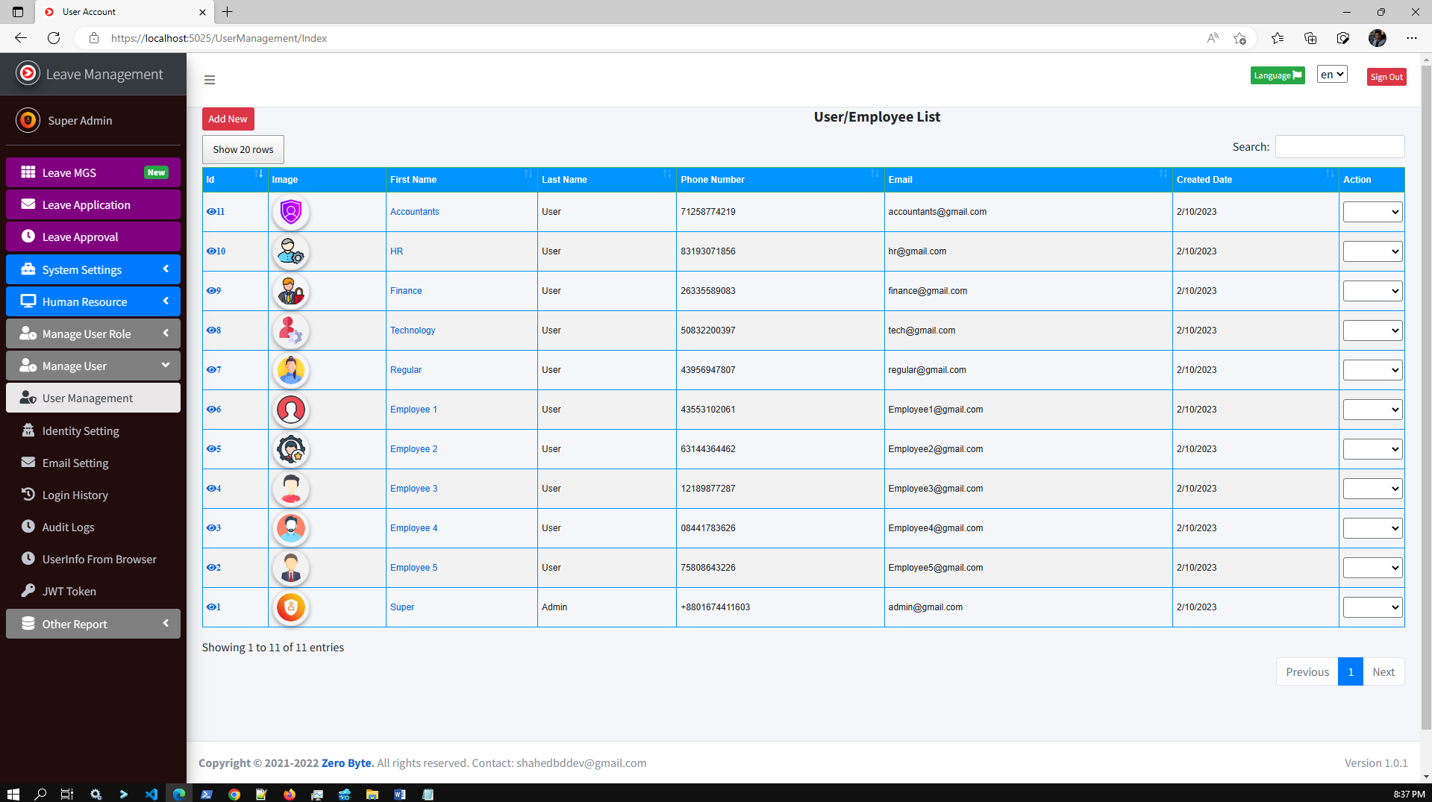

Demo Video:
https://youtu.be/ZmPrd7ItS1s

App Screenshot:
https://photos.app.goo.gl/jDiJbappLY8nZRpt7

DB Migration:
Tools--> Nuget Package Manager--> Package Manager Console

PM> add-migration initcreate
PM> update-database

Check .Net Version:
Press Windows + R.
Type cmd.
On the command prompt, type dotnet --version

FAQ:
Question: How to install Database/How to run migration/Database table not creating?
Answer: Please follow these steps,
1. Make sure the right database connection is in the appsettings.json file
2. Check your server name, by running this SQL: SELECT @@SERVERNAME AS 'Server Name'
3. Delete the database from your SQL Management Studio (if already created)
4. Just build the project (As we have already included Migrations in the project)
5. Run the project
6. Now check your DB. Hopefully, DB and all tables you will find now.
Please cross-check, Program.cs and appsettings.json files properly.

appsettings.json
"DefaultConnectionMSSQL": "Server=DEVSTATION\\MSSQLSERVER2017;Database= LeaveMGS;User ID=sa;Password=dev123456;MultipleActiveResultSets=true",
Note that,
Server = your local server
Database = any name
User ID=your local MSSQL Server user name
Password=your local MSSQL Server user password

Required Application:
- Visual Studio 2022
- MSSQ 2017/later
- Dotnet SDK 6.0

Our Product:
SL | Product
1 | Advance POS System with Stock Manager | ASP.NET Core | EF Core | .NET Core 6.0
2 | Asset Management System with Barcode | ASP.NET Core | EF Core | .NET Core 6.0
3 | Hospital and Pharmacy Management System | ASP.NET Core | EF Core
4 | ASP.NET Core full CRUD with .NET 5 | MSSQL/MySQL | EF code first
5 | Inventory and User Management System
6 | Invoice Gen(Invoice Generation and Management) using .Net Core and EF
7 | Complaint | Issue | Helpdesk Ticket | My Ticket HelpDesk Support System | ASP.NET Core | EF Core
8 | Advanced Files & Users Management | ASP.NET Core | EF Core | .NET Core | MSSQL | MySQL
9 | User Management
10 | Business ERP Solution/Product/POS/Company Management
11 | School/College/University Management ERP
12 | ASP.NET Core CRUD Operation Using Dot Net 6.0 | MVC| MSSQL | MySQL | EF Core Code First | jQuery

Tutorials Video:
How to deploy/host ASP.NET Core 6.0 MVC App to IIS Using VS Code | Visual Studio
How to Install Microsoft SQL Server 2019 and SSMS on Windows 10 | Windows 11| Step By Step

Our YouTube Channel

Supports:
If you want to modify or add new features, or any technical issues you have faced during installation you can always contact us at, shahedbddev@gmail.com
WhatsApp: 8801674411603
Telegram: shahed71bd
Skype: shahedatomap
Email: shahedbddev@gmail.com

